Yifan Yang

40038814

assignment 3

1.

MyArray=["Adam","Eve","Mark","Franklin","John"]

def MySort(array1)

temp=array1.sort

temp.each{|el| puts el+",ch_count="+el.length.to_s}

end

MySort(MyArray)

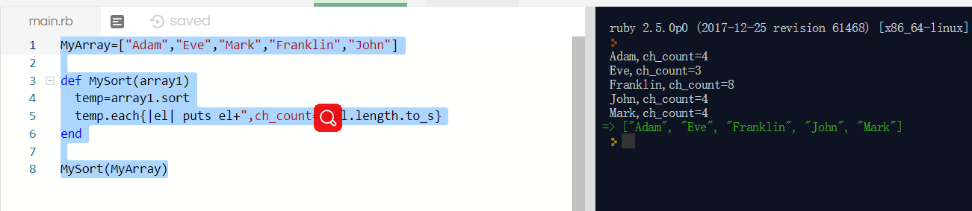

2.

def calcARI(myTXT)

totalChar=0

totalSpace=1

totalDot=0

temp=File.open(myTXT)

for line in temp

s=line.delete(' ')

totalChar+=s.length

totalSpace+=line.count(' ')

totalDot+=line.count('.')

end

puts "Total # of characters: "+totalChar.to_s

puts "Total # of words: "+totalSpace.to_s

puts "Total # of sentences: "+totalDot.to_s

ari=4.71*(totalChar/totalSpace)+0.5*(totalSpace/totalDot)-21.43

puts "Automated Readability Index: "+ari.to_s

print "Grade level: "

case ari

when 1...2

print "5-6(kindergarten)"

when 2...3

print "6-7(first/second grade)"

when 3...4

print "7-9(third grade)"

when 4...5

print "9-10(fourth grade)"

when 5...6

print "10-11(fifth grade)"

when 6...7

print "11-12(sixth grade)"

when 7...8

print "12-13(seventh grade)"

when 8...9

print "13-14(eighth grade)"

when 9...10

print "14-15(ninth grade)"

when 10...11

print "15-16(tenth grade)"

when 11...12

print "16-17(eleventh grade)"

when 12...13

print "17-18(twelfth grade)"

when 13...14

print "18-24(college student)"

else

print "24+(professor)"

end

end

calcARI("myTXT.txt")

txt part：

After the Lord Stanley of Preston was appointed by Queen Victoria as Governor General of Canada on June 11, 1888, he and his family became highly enthusiastic about ice hockey. Stanley was first exposed to the game at Montreal's 1889 Winter Carnival, where he saw the Montreal Victorias play the Montreal Hockey Club. The Montreal Gazette reported that he "expressed his great delight with the game of hockey and the expertise of the players". During that time, organized ice hockey in Canada was still in its infancy and only Montreal and Ottawa had anything resembling leagues.

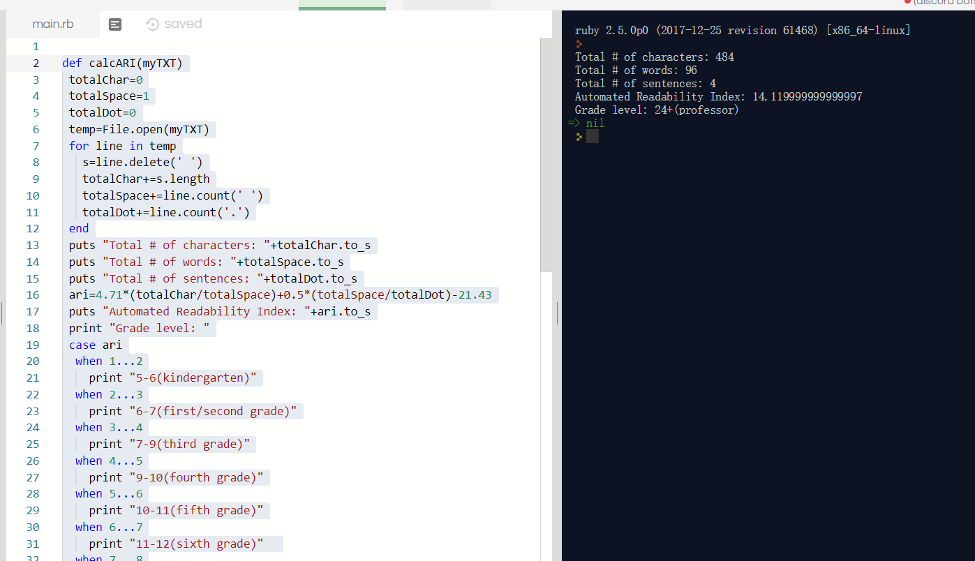

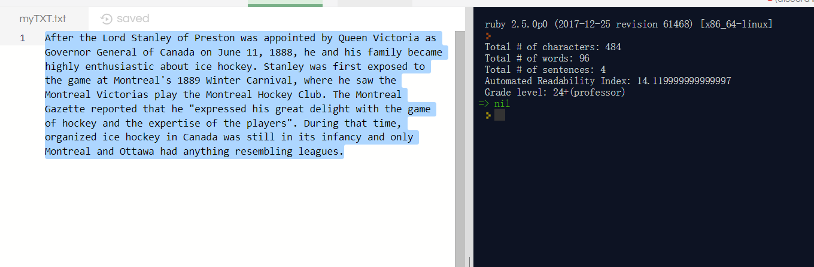

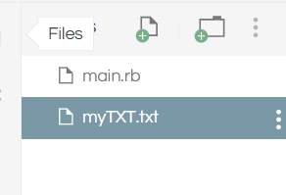

3.

def getData(myTXT)

inputData=[]

temp=File.open(myTXT)

for line in temp

inputData<< ","+line.chomp+","

end

return inputData

end

class BasicFrame

@@total = 0

def initialize(inputData)

@@total += 1

end

def to_s

return ""

end

def BasicFrame.total

return "Number of cars: #@@total"

end

end

class Km<BasicFrame

attr_accessor :km

def initialize (inputData)

super(inputData)

a=/\d+km/i.match(inputData)

@km=a[0]

end

def to_s

return super+@km

end

end

class Car_maker<Km

attr_accessor :car_maker

def initialize (inputData)

super(inputData)

a=/,Honda,|,Toyota,|,Mercedes,|,BMW,|,Lexus,/i.match(inputData)

@car_maker=a[0].delete(",")

end

def to_s

return super+@car_maker

end

end

class Type<Car_maker

attr_accessor :type

def initialize (inputData)

super(inputData)

a=/,Sedan,|,coupe,|,hatchback,|,station,|,SUV,/i.match(inputData)

@type=a[0].delete(",")

end

def to_s

return super+@type

end

end

class Transimission<Type

attr_accessor :transimission

def initialize (inputData)

super(inputData)

a=/,auto,|,manual,|,steptronic,/i.match(inputData)

@transimission=a[0].delete(",")

end

def to_s

return super+@transimission

end

end

class Drivetrain<Transimission

attr_accessor :drivetrain

def initialize (inputData)

super(inputData)

a=/,fwd,|,rwd,|,awd,/i.match(inputData)

@drivetrain=a[0].delete(",")

end

def to_s

return super+@drivetrain

end

end

class Status<Drivetrain

attr_accessor :status

def initialize (inputData)

super(inputData)

a=/,used,|,new,/i.match(inputData)

@status=a[0].delete(",")

end

def to_s

return super+@status

end

end

class Year<Status

attr_accessor :year

def initialize (inputData)

super(inputData)

a=/,\d{4},/i.match(inputData)

@year=a[0].delete(",")

end

def to_s

return super+@year

end

end

class Trim<Year

attr_accessor :trim

def initialize (inputData)

super(inputData)

a=/,[A-Z]{2},/i.match(inputData)

@trim=a[0].delete(",")

end

def to_s

return super+@trim

end

end

class Sets<Trim

attr_accessor :sets

def initialize (inputData)

super(inputData)

a=/{.*}/i.match(inputData)

@sets=a[0]

end

def to_s

return super+@sets

end

end

class Fuel<Sets

attr_accessor :fuel

def initialize (inputData)

super(inputData)

a=/,(\d*|\d*\.\d)L\/\d*km,/i.match(inputData)

@fuel=a[0].delete(",")

end

def to_s

return super+@fuel

end

end

class Model<Fuel

attr_accessor :model

def initialize (inputData)

super(inputData)

tempa=inputData.gsub!(@km, "")

tempa=inputData.gsub!(@car_maker, "")

tempa=inputData.gsub!(@drivetrain, "")

tempa=inputData.gsub!(@trim, "")

tempa=inputData.gsub!(@sets, "")

tempa=inputData.gsub!(@status, "")

tempa=inputData.gsub!(@fuel, "")

tempa=inputData.gsub!(@type, "")

tempa=inputData.gsub!(@transimission, "")

tempa=inputData.gsub!(@year, "")

a=/,[a-z]+,/i.match(tempa)

@model=a[0].delete(",")

end

def to_s

return super+@model

end

end

class Stock<Model

attr_accessor :stock

def initialize (inputData)

super(inputData)

tempa=inputData.gsub!(/,(\d*|\d*\.\d)L\/\d*km,/i, "")

tempa=inputData.gsub!(@km, "")

tempa=inputData.gsub!(@car_maker, "")

tempa=inputData.gsub!(@drivetrain, "")

tempa=inputData.gsub!(@trim, "")

tempa=inputData.gsub!(@sets, "")

tempa=inputData.gsub!(@status, "")

tempa=inputData.gsub!(/8L\/10/i, "")

tempa=inputData.gsub!(@type, "")

tempa=inputData.gsub!(@transimission, "")

tempa=inputData.gsub!(@year, "")

tempa=inputData.gsub!(@model, "")

@stock=tempa.gsub!(",", "")

end

def to_s

return super+@stock

end

end

def convertListings2Catalougue(myList)

inputData=getData(myList)

i=0

myCatalog=[]

while i < inputData.length do

p=Stock.new(inputData[i])

q=p.car_maker+","+p.model+","+p.trim+","+p.km+","+p.year+","+p.drivetrain+","+p.transimission+","+p.stock+","+p.status+","+p.fuel+","+p.sets

myCatalog<<q

i +=1

end

return myCatalog

end

def searchInventory(myinput)

myinput=myinput.to_s

a=/=>.*/i.match(myinput)

i=0

a=a.to_s

a=a.delete("=>")

a=a.delete("\"")

a=a.delete("}")

File.open("myTXT.txt").each { |line| puts line if line.include? a

}

end

def Add2Inventory(mylist)

temp = File.new("myTXT.txt", "a+")

temp.syswrite("\n")

temp.syswrite(mylist)

mytemplist=","+mylist+","

p=Stock.new(mytemplist)

q=p.car_maker+","+p.model+","+p.trim+","+p.km+","+p.year+","+p.drivetrain+","+p.transimission+","+p.stock+","+p.status+","+p.fuel+","+p.sets

return q

end

def saveCatalogue2File(mycatalog)

temp=mycatalog.sort

aFile = File.new("final.txt", "a+")

i=0

while i < temp.length do

aFile.syswrite(temp[i])

aFile.syswrite("\n")

i +=1

end

end

puts "mycatalogtest"

myCatalog=convertListings2Catalougue("myTXT.txt")

puts BasicFrame.total

puts myCatalog

puts "--------------------------------------------------"

puts "addtest"

myCatalog<<Add2Inventory("coupe,1100km,auto,RWD,Mercedes,CLK,LX,18FO724A,2017,{AC, Heated Seats, Heated Mirrors, Keyless Entry, Power seats},6L/100km,Used")

puts BasicFrame.total

puts myCatalog

puts "--------------------------------------------------"

puts "savetest,you should check final.txt"

saveCatalogue2File(myCatalog)

puts "--------------------------------------------------"

puts "searchtest"

searchInventory ({"car_maker" => "Mercedes"})

my original txt files

mytxt(input file)

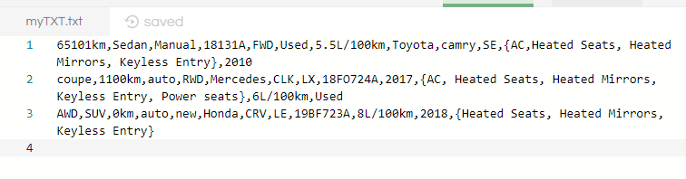

finaltxt(output file)

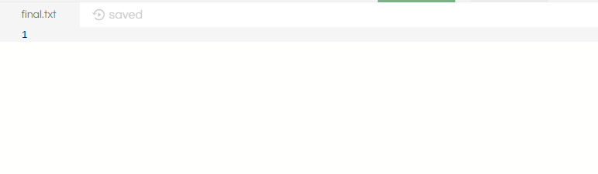

1. *convertListings2Catalougue*

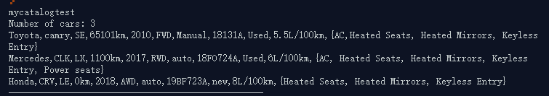

2.search(use medeces here)

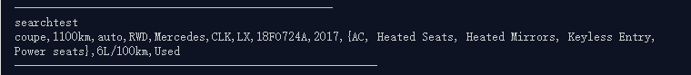

3.add to list (i add a “coupe,1100km,auto,RWD,Mercedes,CLK,LX,18FO724A,2017,{AC, Heated Seats, Heated Mirrors, Keyless Entry, Power seats},6L/100km,Used”)

(1)we need to make sure we add a new unordered item into original input txt

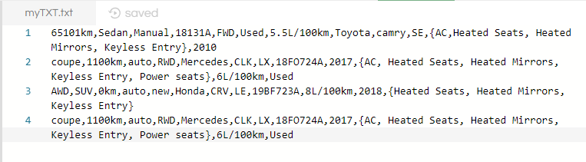

(2) we need to add a order element into my catalog

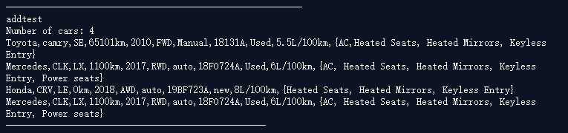

4.save to file (cause we add a new mercedes before, so now we have 4 cars)

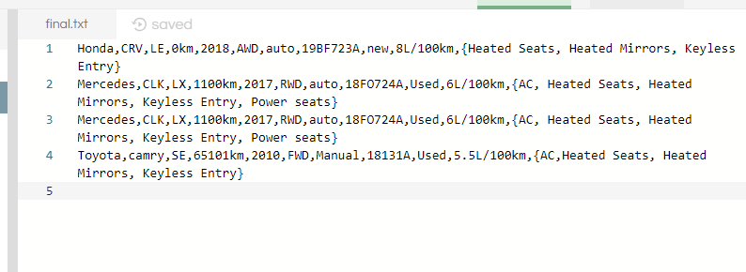

total

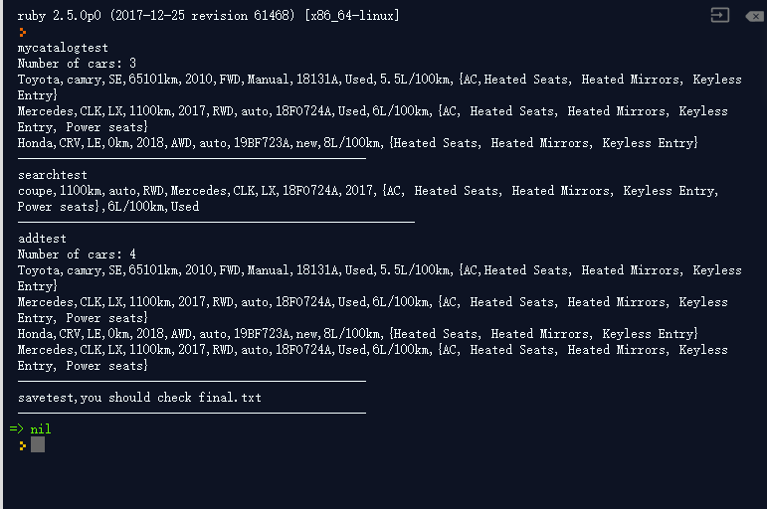

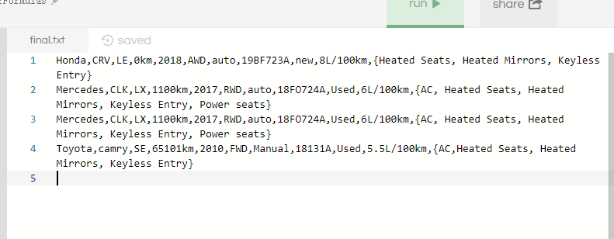

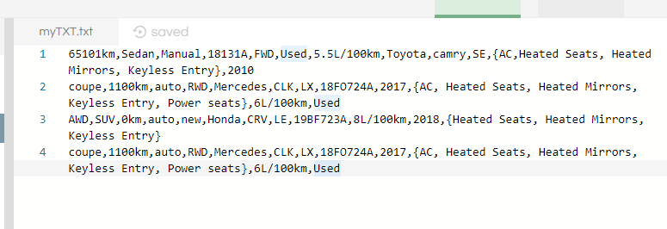

#include<stdio.h>

void main()

{

int array[2][3],b[3][2];

int i,j;

printf("input:\n");

for(i=0;i<2;i++)

for(j=0;j<3;j++)

{scanf("%d",&array[i][j]);}

printf("\n");

for(i=0;i<2;i++)

{

for(j=0;j<3;j++)

printf("%d ",array[i][j]);

printf("\n");

}

int t;

for(i=0;i<2;i++)

for(j=0;j<3;j++)

{

t=array[i][j];

array[i][j]=b[j][i];

b[j][i]=t;

}

printf("\n");

printf("output");

printf("\n");

printf("\n");

for(i=0;i<3;i++)

{

for(j=0;j<2;j++)

printf("%d ",b[i][j]);

printf("\n");

}

}

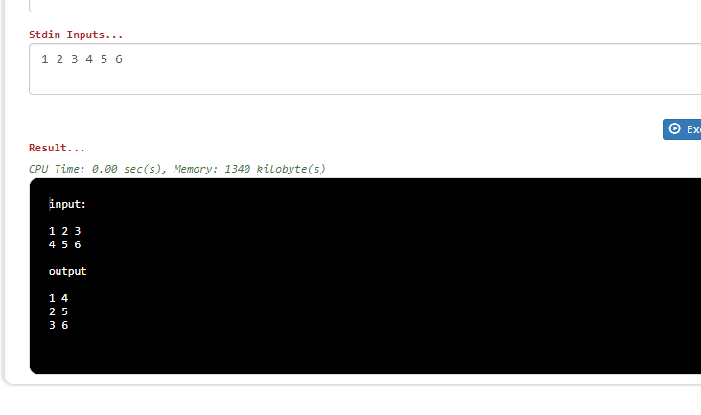

5.

#include<stdio.h>

#include<malloc.h>

#include<stdlib.h>

struct car_maker {

char maker;

struct car_maker *next;

struct car_model *below;

};

struct car_model {

char model;

struct car_model *next;

struct car_trim *below;

};

struct car_trim {

char trim;

struct car_trim *next;

struct car_km *below;

};

struct car_km {

char km;

struct car_km *next;

struct car_year *below;

};

struct car_year {

int year;

struct car_year *next;

struct car_type *below;

};

struct car_type {

char type;

struct car_type *next;

struct car_transimission *below;

};

struct car_transimission {

char transimission;

struct car_transimission *next;

struct car_stock *below;

};

struct car_stock {

char stock;

struct car_stock *next;

struct car_status *below;

};

struct car_status {

char status;

struct car_status *next;

struct car_fuel *below;

};

struct car_fuel {

char fuel;

struct car_fuel *next;

struct car_sets *below;

};

struct car_sets {

char sets;

struct car_sets *next;

};

int main() {

struct car_maker *head = NULL;

struct car_maker *new;

head = malloc(sizeof(struct car_maker));

if (head == NULL)

head->maker = "Honda";

head->next = NULL;

newcar = malloc(sizeof(struct car_maker));

if (new == NULL) {...}

newcar->maker = "Mercedes";

newcar->next = head;

head = new;

newcar1 = malloc(sizeof(struct car_maker));

if (newcar1 == NULL) {...}

newcar1->maker = "Toyota";

newcar1->next = head;

head = new;

printf("%d ", head->car_maker);

printf("%d ", (head->next)->car_maker);

return 0;

}